**FORMS (Module 7)**

1. Create a form using new input types of HTML5. 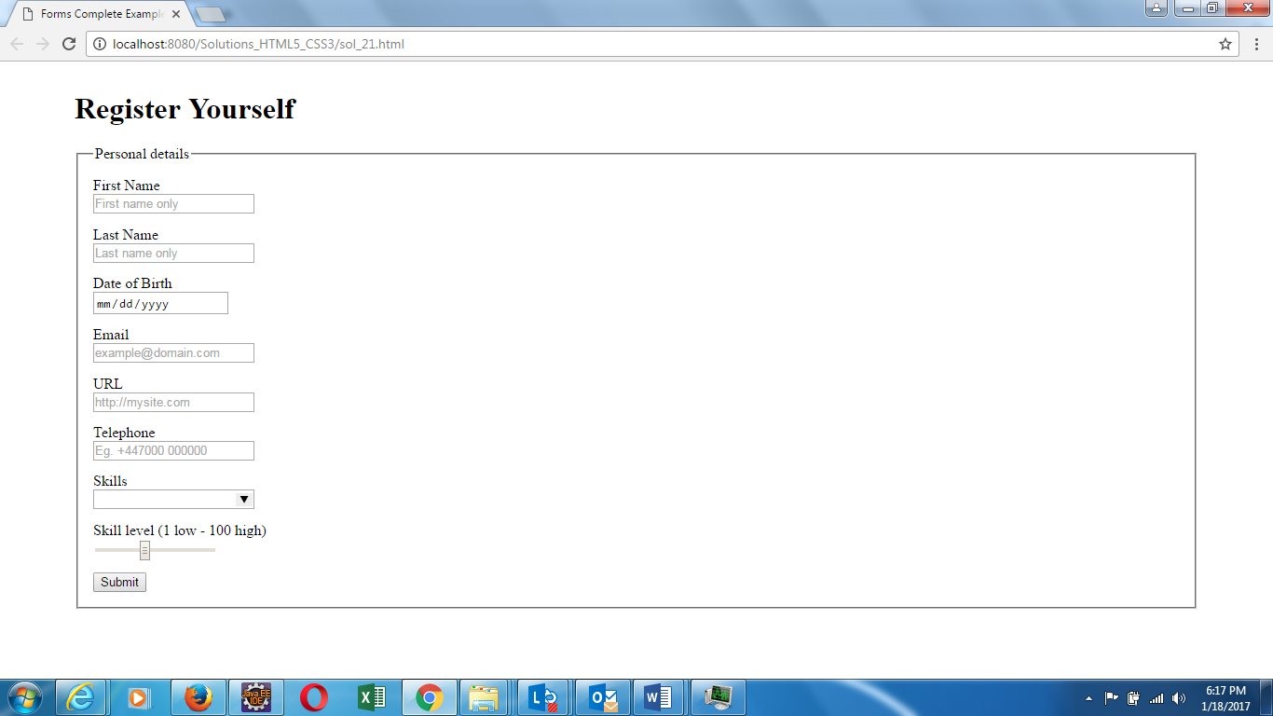
2. Create a form for e-commerce website using HTML5 new input types and validations that accepts user details and payment details to place an order online.

